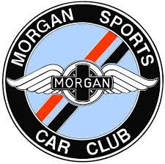 | MSCC AutoSolo 2022
 | supported by
To be held on 23 July 2022 at the British Motor Museum, Gaydon, Warwickshire, CV35 0BJ
Entry Form
Name:
Membership no:
*Motorsport UK licence number:
Address, incl. postcode:
Email:
Contact number:
I am aged 18 years or over: | Yes / No (delete as applicable) | Age if under 18:
If <18yo, name and address of guardian and relationship to entrant:
Class entered:  (delete not-applicable) | i. Morgan 4-cylinder ii. Morgan 6-, 8-cylinder or CX-chassis  iii. Morgan Expert iv. Non-Morgan car
Make, model & engine capacity:
Year of manufacture:
Vehicle registration number:
Emergency contact:
(name, address, phone, relationship)
Please make payment of £25.00 electronically to ‘Morgan Sports Car Club Ltd’, sort code 30-94-97, account no. 00039156. Please use your MSCC membership number followed by ‘SOLO’ as the reference, i.e. 12345SOLO, so your payment can be matched to the entry.
Please return this form to Iain Leviston, MSCC Motorsport Lead, via email at SportsMog@MorganSportsCarClub.com. An email confirmation will be sent when the entry form and payment are received.
Signature of driver:
Signature of guardian if <18yo:
*A Motorsport UK RS Clubman licence minimum must be held to compete. These can be obtained FREE OF CHARGE from www.motorsportuk.org/competitors/rs-clubman-licence/
Held under the General Regulations of Motorsport UK (incorporating the provisions of the International Sporting Code of the FIA) and these Supplementary Regulations.

